**COMSATS University Islamabad,   
Abbottabad Campus**

**Project Proposal   
(SCOPE DOCUMENT)**

**for**

**FurnishARt (An AR-Based Furniture Store)**  
Version 1.0

***By***

1. **Muhammad Umer CIIT/SP21-BCS-016/ATD**
2. **Muhammad Noman CIIT/SP21-BCS-014/ATD**
3. **Hafiz Talha Nazir CIIT/SP21-BCS-007/ATD**

***Supervisor***Mam Bushra Mushtaq

***Bachelor of Science in Computer Science (2021-2025)***

|  |  |  |
| --- | --- | --- |
| **No.** | **Comment** | **Action** |
|  |  |  |
|  |  |  |
|  |  |  |
|  |  |  |
|  |  |  |
|  |  |  |

**SCOPE DOCUMENT REVSION HISTORY**

**Supervisor Signature Date:**

**Table of Contents**

**1.** **Introduction 4**

**2.** **Problem Statement 5**

**3.** **Problem Solution for Proposed System 5**

**4.** **Related System Analysis/Literature Review 5**

**5.** **Advantages/Benefits of Proposed System 5**

**6.** **Scope 6**

**7.** **Modules 6**

7.1 Module 1: Module Name 6

7.2 Module 2: Module Name 6

**8.** **System Limitations/Constraints 6**

**9.** **Software Process Methodology 6**

**10.** **Tools and Technologies 7**

**11.** **Project Stakeholders and Roles 7**

**12.** **Team Members Individual Tasks/Work Division 8**

**13.** **Data Gathering Approach 8**

**14.** **Concepts 8**

**15.** **Gantt chart 9**

**16.** **Mockups 10**

**17.** **Conclusion 11**

**18.** **References 11**

**19.** **Plaragism Report 11**

**Project Category: (**Select all the major domains of proposed project**)**

* A-Desktop Application/Information System
* B-Web Application/Web Application based Information System
* C- Problem Solving and Artificial Intelligence
* D-Simulation and Modeling
* E- Smartphone Application
* F- Smartphone Game
* G- Networks
* H- Image Processing
* Other (specify category) _____________________

**Abstract**

The project's goal is to create an augmented reality (AR)-based Online Furniture Store website that incorporates 3D furniture models. Customers may view and interact with virtual 3D furniture models in their physical environment by using the cameras on their phones, which helps them make well-informed purchases. By offering a unique method of seeing furniture before making a purchase, the platform improves the customer experience and closes the gap between online and offline buying.

**Introduction**

The rise of **Augmented reality (AR)** technology has revolutionized the way we interact with digital content, blurring the lines between the virtual and physical worlds. In the context of e-commerce, **Augmented reality (AR)** offers unprecedented opportunities to enhance the online shopping experience by allowing customers to visualize products in their real-world environment before making a purchase.

1. Project aims to develop AR-based Online Furniture Store web application.
2. Utilize AR technology for immersive shopping experience.
3. Enable users to view and interact with 3D product models in their own space.
4. Integration of AR functionality directly into the platform.
5. Empower users to make informed purchasing decisions.
6. Enable customers to choose wisely when making purchases.
7. Revolutionize online shopping experience.
8. Gain competitive edge in evolving e-commerce landscape.

**Problem Statement**

Traditional online furniture shopping presents several challenges for customers, including:

**1. Visualization and Confidence:**

* Difficulty visualizing how furniture will look and fit in their living spaces.
* Lack of confidence in purchasing decisions due to uncertainty.

**2. Increased Returns:**

* Surprises upon delivery due to the lack of context in online product displays.
* Higher return rates leading to increased costs for businesses and inconvenience for customers.

**3. Engagement Limitations:**

* Limited engagement with static online product displays.
* Inability to replicate the immersive experience of physical showroom exploration.

By embarking on this project, we aim to transform the online shopping experience, boost customer satisfaction, and gain a competitive edge in e-commerce. Despite existing systems, re-implementing one offers hands-on learning in AR development, e-commerce integration, and UI design, essential for skill acquisition and innovation.

## Expected Skills Acquired:

* Proficiency in AR development frameworks.
* Proficiency in implementing and optimizing 3D model viewing features.
* Database management for e-commerce platforms.
* Understanding of user-centric design principles.
* Interactive website Development

**Problem Solution for Proposed System**

## System Features:

* User-friendly AR interface for viewing and interaction with 3D furniture models.
* Minimize surprises upon delivery by enabling customers to preview furniture within their desired spaces .
* Bridging the gap between online product listings and real-world experiences.

## Empowerment Through Experience:

* Enable users to make confident purchasing decisions.
* Seamless integration with e-commerce functionalities.
* Intuitive navigation for exploring product details.

## Enhanced User Experience:

* Accurate scaling and realistic rendering of furniture models.
* Authentic AR experience aids in decision-making process.
* Seamless purchase process for enhanced convenience.

**Related System Analysis with proposed project solution**

|  |  |  |
| --- | --- | --- |
| **Application Name** | **Weakness** | **Proposed Project Solution** |
| **VSurface** | It lacks AR previews for furniture items, restricting its functionality to rugs only. | This system provides AR previews for a broader range of furniture items. |
| **IKEA Place** | The app's interface is complex or difficult to the end user – and IKEA is not available in Pakistan. | Our system will provide user friendly interface and this system will be launching in Pakistan. |
| **Wayfair Spaces** | Their Website is overwhelming and cluttered at times, with vast variety of products, categories, and subcategories to choose from. The website can be slow and laggy at times and Wayfair is not available in Pakistan. | We propose simplifying product categorization, optimizing the website for faster loading times, and refining subcategory structures. |

**Advantages/Benefits of Proposed System**

* **Enhanced User Experience:** AR enhances shopping by providing an immersive experience, boosting engagement and satisfaction.
* **Reduced Returns:** Visualizing products in AR reduces returns by aligning customer expectations with reality.
* **Competitive Advantage:** Implementing AR differentiates the platform, showcasing innovation and customer-centricity.
* **Increased Sales:** AR previews lead to higher conversion rates and sales as customers gain confidence.
* **Improved Brand Perception:** Offering AR technology enhances the brand's image as forward-thinking and customer focused.

**Scope**This proposed project will be a web-based Furniture Store application built for a single furniture seller. The core functionality will utilize AR technology to bridge the gap between the virtual furniture and the customer's physical space.

The proposed project will be able to:

* Integrate the AR technology for viewing 3D models of furniture on the web platform.
* Superimpose furniture models onto the customer's real-world environment via smartphone camera.
* Facilitate customers to assess the size of furniture items at their own place before purchase.
* Include single seller marketplace.
* Focus solely on furniture products without additional functionalities.

**Modules**

## 3D Model Management:

This module oversees management of 3D models for furniture items within the inventory. It ensures accurate generation and storage of detailed models, including dimensions, textures, and materials. Additionally, it will facilitate admin to add, view, modify, and remove models seamlessly from Admin Panel. This integrated functionality streamlines the efficient management of the 3D model database.

## Augmented Reality Preview Mode:

This module enables AR mode for viewing furniture products in real environments using mobile devices' cameras. Users can accurately place furniture items within their own spaces to visualize how they fit and complement their surroundings.

## 3D Model Viewing:

Enhancing the listing interface, this module incorporates interactive 3D models alongside traditional product images and descriptions. Users can rotate, zoom, and interact with 3D models directly within the listing, gaining a deeper understanding of each furniture item.

## Furniture Exploration and Reviews:

This module combines the functionality of browsing furniture listings with the management of customer reviews. Users can explore a comprehensive catalog of furniture items, filter search results, and access detailed product information. Additionally, they can leave feedback and view reviews from other customers, enhancing the overall shopping experience. Special features include dynamic loading and pagination for optimized performance and smooth navigation through extensive catalogs.

## User Registration and Authentication:

Handles user registration, sign-up, sign-in, and account editing functionalities. This module ensures secure access to the platform, verifies user identities, and manages user profiles.

## Secure Payment:

This module guarantees the security and dependability of online transactions by seamlessly integrating a secure payment gateway into both the backend and frontend of the platform. Notably, it supports multiple payment methods, providing enhanced convenience for users with options such as credit/debit cards, digital wallets, and other online payment solutions.

## Admin Panel:

The Admin Panel provides administrators with a centralized interface to manage 3D models of furniture and furniture items efficiently. It enables CRUD operations for both 3D models and furniture items. Administrators can add new items, review existing ones, and make necessary edits or deletions to maintain the integrity of the catalog.

**System Limitations/Constraints**

While our proposed Augmented Reality-Based Online Furniture Store promises to revolutionize online shopping experiences for furniture, it's essential to recognize its limitations and constraints:

1. **Device Compatibility:** The AR functionality heavily relies on the capabilities of user’s mobile devices, including camera quality and processing power. Compatibility issues may arise if user's devices do not meet the necessary requirements for seamless AR experiences.
2. **Internet Connectivity:** Since the proposed project is web-based, it relies on stable internet connectivity for users to access and interact with the platform effectively. Limited or unreliable internet connections may hinder the user experience, especially during AR mode usage where real-time rendering and data streaming are crucial.
3. **Hardware Limitations:** The complexity of rendering 3D models and AR experiences may pose limitations on older or less powerful devices, leading to performance issues such as slow loading times or laggy interactions. This could impact user satisfaction and adoption rates, particularly among users with less advanced hardware.
4. **Payment Method Constraints:** Accepting only Visa and Mastercard may limit accessibility for users who prefer alternative payment methods. Some users may not have access to these payment options or may prefer to use other services, potentially leading to reduced conversion rates and customer satisfaction.

**Software Process Methodology**

An Agile software development methodology would be most suitable. Agile allows for iterative development. Agile methodology is chosen for its flexibility, adaptability, and focus on delivering value to customers. Agile methodology enables efficient development and integration of AR functionality into the online furniture store.

**Agile Methodology**  
Chosen for its flexibility, adaptability, and customer value focus, agile enables efficient development and integration of AR functionality into the online furniture store through iterative cycles.

**Object-Oriented Programming (OOP) Approach**  
OOP principles are utilized for modular, maintainable, and scalable code. Encapsulation promotes code reusability and readability. The structured approach aligns with Agile, facilitating collaborative development with React/Next.js for frontend and Node.js for backend.

**Tools and Technologies**  
React/Next.js for frontend and Node.js for backend, chosen for their alignment with Agile principles, facilitate rapid development and easy feature integration.

**Design Approach**  
Agile's user-centric approach complements FurnishARt's needs, fostering responsive interfaces and scalable systems with React/Next.js and Node.js.

**Expertise and Needs**  
Agile, widely used for its adaptability, suits FurnishARt's complex AR integration process, enabling continuous improvement based on user feedback.

**Tools and Technologies**

|  |  |  |
| --- | --- | --- |
| **Tools** | **Version** | **Rationale** |
| MS Visual Studio Code | 1.87 | IDE |
| PostgreSQL | 16.2 | DBMS |
| MS Word | 2019 | Documentation |
| MS PowerPoint | 2019 | Presentation |
| JavaScript | ES6 | Programming language |
| SQL | 2013 | Query Language |
| React.js /Next.js/Three.js | Latest | Frontend Web Development |
| AR.js/Unity | Latest | 3D modeling and AR Preview |
| Node.js / Express | 20 / 4.1 | Backend Web Development |
| Postman | 10 | Testing |
| Git and Github | 2.44.0 | Version Control |

**Project Stakeholders and Roles:**

|  |  |
| --- | --- |
| **Project Sponsor** | COMSATS University, Islamabad, providing support and oversight for project development. |
| **Stakeholder** | Students (Developers):  Muhammad Umer **(SP21-BCS-016)** Muhammad Noman **(SP21-BCS-014)**  Hafiz Talha Nazir **(SP21--BCS-007) Project Supervisor:**  Mam Bushra Mushtaq: She is responsible for guiding, advising, and overseeing the project's progress.  **Final Year Project Committee:**  Evaluation of the project's outcome, providing feedback, and assessing its quality and adherence to project guidelines. |

# Team Members Individual Tasks/Work Division:

|  |  |  |
| --- | --- | --- |
| **Student Name** | **Student Registration Number** | **Responsibility/Modules** |
| Hafiz Talha Nazir | SP21-BCS-007 | Frontend development with React/Next.js (All Modules) |
| Muhammad Umer | SP21-BCS-016 | Backend development using Node and Express (All Modules) – Database Management. |
| Muhammad Noman | SP21-BCS-014 | Implementing Augmented Reality (AR) functionalities for store. |
| Mam Bushra Mushtaq (Supervisor) | - | Guidance, advising, and project oversight |

**Data Gathering Approach**

For the AR-based furniture store project, data gathering will involve a combination of interviews, surveys, and observational studies. Interviews with potential users and stakeholders will provide qualitative insights into their preferences and expectations regarding AR technology in furniture shopping. Surveys distributed to a wider audience will gather quantitative data on user demographics, AR usage habits, and preferences for furniture shopping. Observational studies will analyze user interactions with existing AR-based furniture applications, informing the development of a user-centric and immersive AR experience for the furniture store.

**Concept:**

1. **Augmented Reality (AR):** Understanding the fundamentals of AR technology and its application in enhancing the online shopping experience by overlaying virtual furniture models onto real-world environments.
2. **3D Modeling:** Learning the principles and techniques of creating detailed and accurate 3D models of furniture items to be integrated into the AR-based platform for visualization.
3. **User Experience Design:** Exploring concepts related to designing intuitive and engaging user interfaces for seamless navigation and interaction with AR features, ensuring a positive shopping experience.
4. **E-commerce Integration:** Understanding the process of integrating AR functionality into an existing e-commerce platform, including backend systems and databases, to facilitate the display and management of virtual furniture items.

**Gantt chart:**

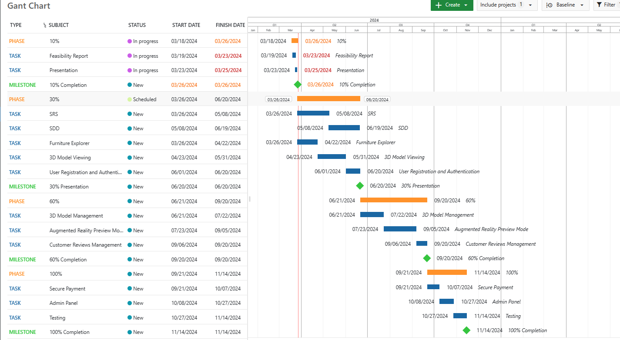

Figure 1: Gantt chart

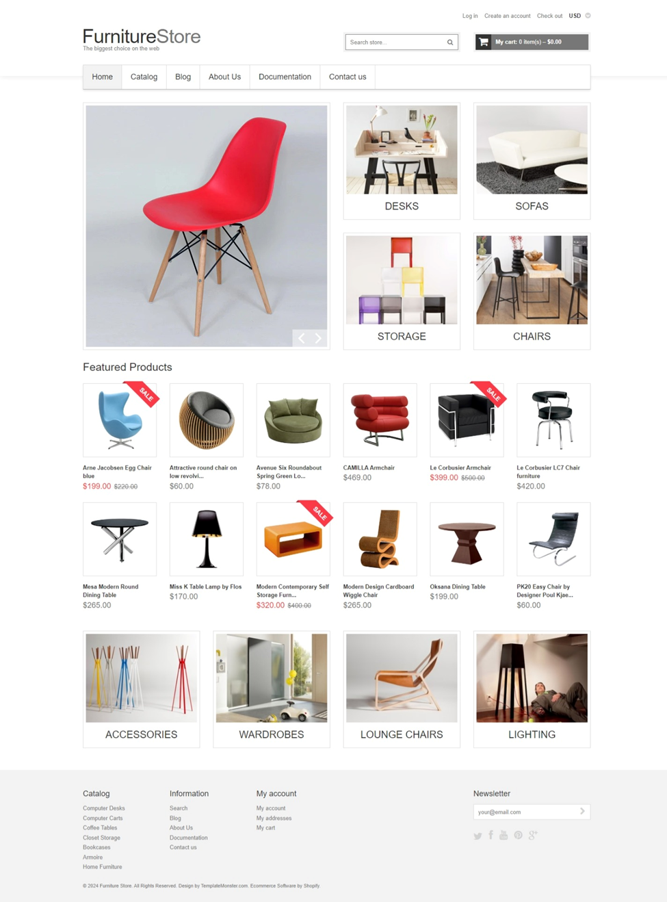**Mockups**

Figure 2: Home page design

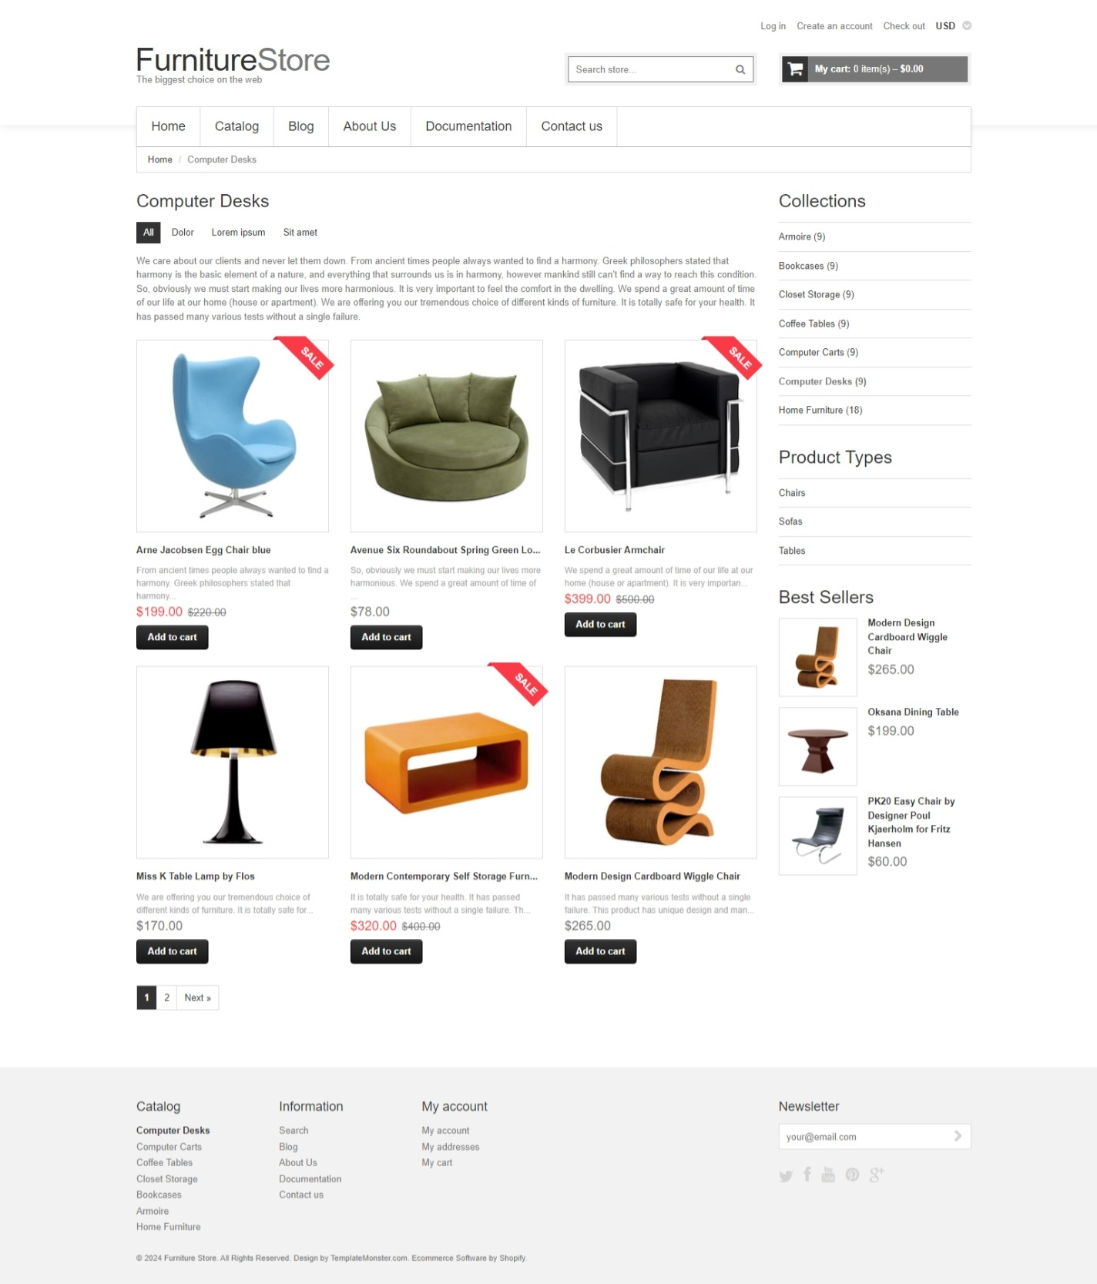

Figure 3: Catalog page design

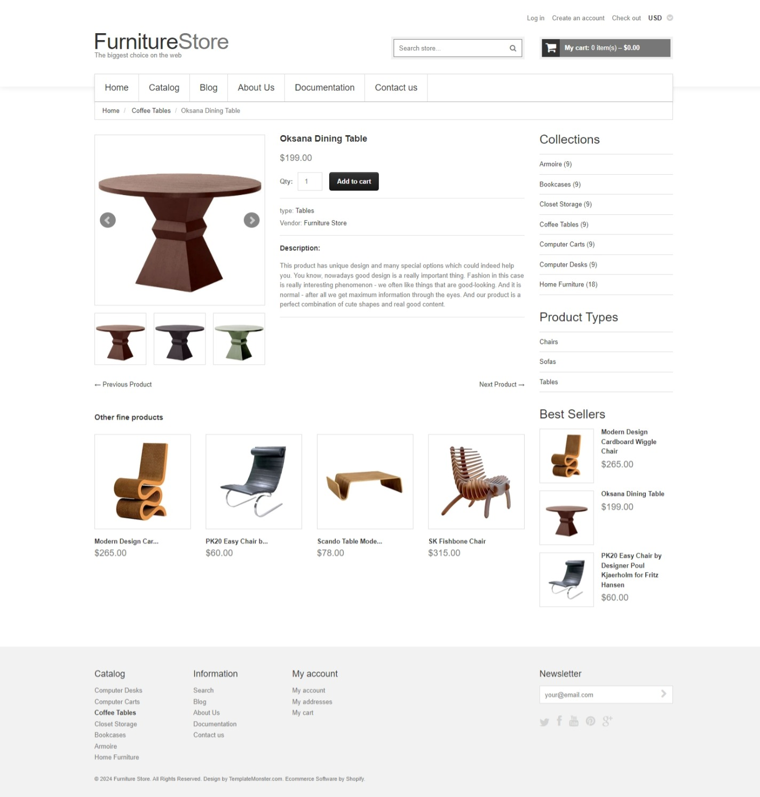

Figure 4: Product page design

**Conclusion**

In conclusion, the proposed AR-based furniture store project presents an innovative solution to revolutionize the online furniture shopping experience. By leveraging augmented reality technology, users will be able to visualize furniture items in their own living spaces before making a purchase, enhancing decision-making and reducing uncertainty. Through a comprehensive data gathering approach and exploration of key concepts such as AR, 3D modeling, user experience design, and e-commerce integration, the project aims to deliver a user-centric platform that addresses the evolving needs and expectations of modern furniture shoppers. With a focus on seamless integration, immersive experiences, and user satisfaction, this project holds the potential to redefine the way people shop for furniture online.

# References:

[Wayfair’s UX Review : User-Centered Design in Practice | by Samy Vahdat | Barno Studio | Medium](https://medium.com/@barnoteam/wayfairs-ux-review-user-centered-design-in-practice-1cbee1e308bc)

<https://www.ikea.com/>

https://www.wayfair.com/